Abstract Title Centred and Bold in Upper and Lower Case
(Calibri Bold 14pt centred)

First name Family name (Surname)¹ and First name Family name (Surname)^{2*}
(Example: Jane Smith¹, Jan Nowak^{2*}) (Calibri Bold 12pt centred)

¹Department/Research Institute, University, Country
²Department/Research Institute, University, Country,*email@presenting.author (Calibri 9pt centred, add hyperlink)

Abstract (Calibri Bold 11pt, spacing 5pt after)
(Calibri 10pt justified) Kindly follow this template to fulfil the format requirements for WOCSDICE EXMATEC 2026 extended abstract. It must not exceed 2 pages (4 pages for Invited Speakers) in a two-column format with a fully justified text (single-spaced) and should include the following sections: Abstract (to provide a brief summary of your extended abstract); Introduction; Experimental details; Results and discussion; Conclusions; Acknowledgements; References (Please cite your references only in that section, the abstract should not include any references).
Tables and figures can be included (in colour or not). The extended abstract is intended to describe the authors’ work with sufficient detail to allow its evaluation by the reviewers’ panel. A blank line should be left between the different sections, tables or figures. Times New Roman size font indicated in the different sections must be used: simply copy and paste your text over the material in this document. Pagination should not be inserted. Please note that the extended abstracts will be published in the Conference’s abstract book, but will only be visible to conference attendees.
Introduction (Calibri Bold 11pt, spacing 5pt after)
(Calibri 10pt justified) The introduction should describe the scope, fundamentals and background of the work presented, with adequate citations to frame and support your results. Additionally, the authors should specify the addressed hypothesis and aims. References must be sequentially ordered and the numbers should be indicated in brackets [1,2,…].
Experimental / Computational Details (Calibri Bold 11pt, spacing 5pt after)
(Calibri 10pt justified) This section should specify exactly the technique, experimental set up and/or procedure used in conducting this study.
Results and discussion (Calibri Bold 11pt, spacing 5pt after)
(Calibri 10pt justified) Authors should consider how to present their results in a clear and comprehensive way. Tables, figures and equations may be used in this section. There should be sufficient information for the reader to understand, although it is not necessary to write an extensive text to explain all the details.
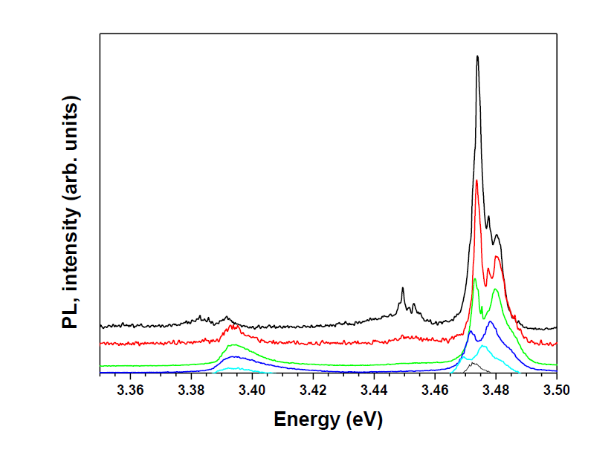

Figure 1 (TNR Bold 8pt). Centre the figure in the column and insert a caption below each figure. (TNR 8pt justified)

Column Head Samples | 1 | 2 | 3
Measurements result | 22.52 | 12.16 | 10.75
CogTool prediction | 22.72 | 12.26 | 10.60

Table 1 (TNR Bold 8pt). Centre the table in the column and insert a caption below each table. (TNR 8pt justified)

Discussion should summarize the observations and place the results into the context of the reported results in the literature, as well as express an opinion regarding the significance of the work.
Conclusions (Calibri Bold 11pt, spacing 5pt after)
(Calibri 10pt justified) The conclusion may review the main points of the paper and elaborate on the importance of the work or suggest applications and extensions. It should not replicate the abstract.
Acknowledgments (Calibri Bold 11pt, spacing 5pt after)
(Calibri 10pt justified) Authors should acknowledge any person or funding agency that has made a significant contribution to the work.
References (Calibri Bold 11pt, spacing 5pt after)
(Calibri 10pt justified) References must be numbered using the following style: Authors Family name (Surname), first letter of First name, journal, volume, pages, year (e.g., [1] Smith, J. et al., J. Phys. Com. 2, 5-11, 2011).

